**DAILY ONLINE ACTIVITIES SUMMARY**

|  |  |  |  |  |  |  |  |  |
| --- | --- | --- | --- | --- | --- | --- | --- | --- |
| **Date:** | **27-7-2020** | | | | | **Name:** | **Pavana P** | |
| **Sem & Sec** | **6A** | | | | | **USN:** | **4AL17CS057** | |
| **Online Test Summary** | | | | | | | | |
| **Subject** | |  | | | | | | |
| **Max. Marks** | |  | | **Score** | | |  | |
| **Certification Course Summary** | | | | | | | | |
| **Course** | **Introduction to Big Data** | | | | | | | |
| **Certificate Provider** | | | Coursera | | **Duration** | | | 4 weeks |
| **Coding Challenges** | | | | | | | | |
| **Problem Statement:**  1.Python Program for Largest K digit number divisible by X | | | | | | | | |
| **Status: Completed** | | | | | | | | |
| **Uploaded the report in Github** | | | | | **YES** | | | |
| **If yes Repository name** | | | | | **DAILY STATUS** | | | |
| **Uploaded the report in slack** | | | | | **YES** | | | |

**CERTIFICATION COURSE**

**Introduction to Big Data**

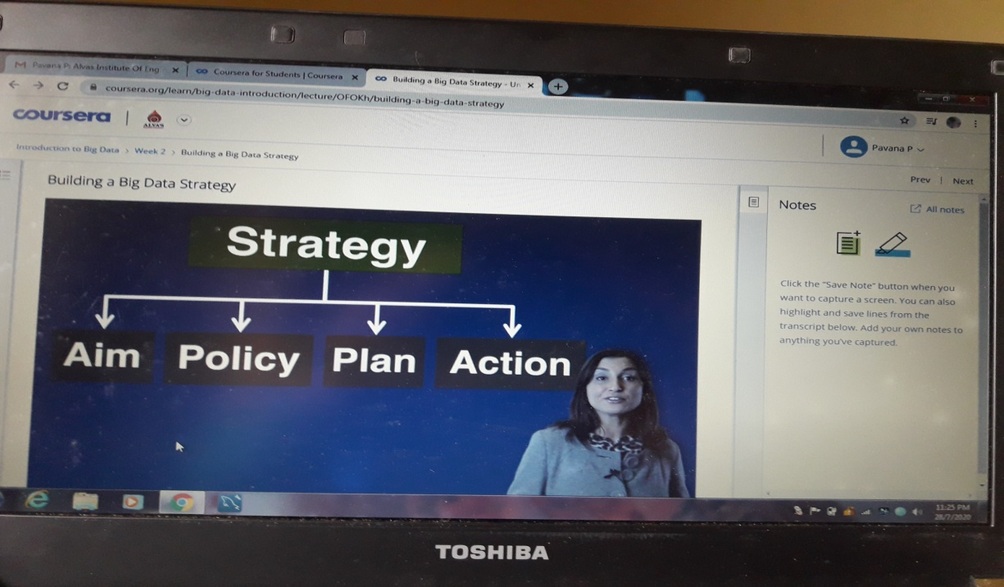

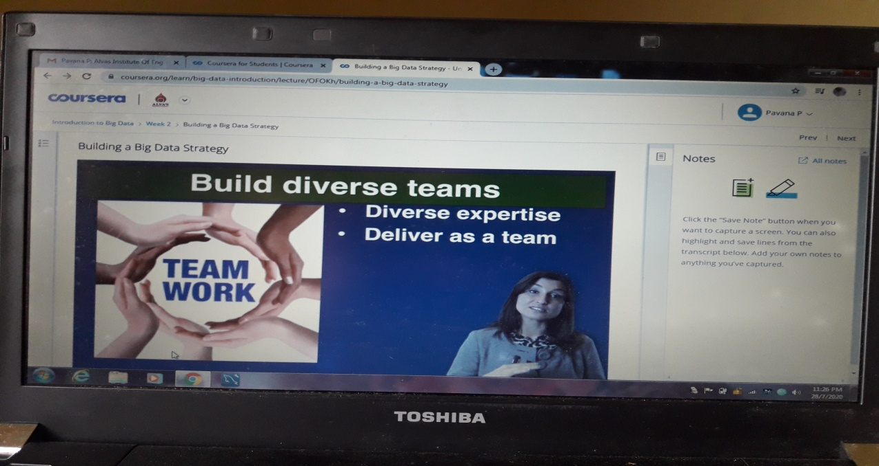

**Coding Challenges Details:**

[**https://github.com/pavana-p-kulal/DAILY-STATUS/tree/master/27-7-20/Online%20Coding**](https://github.com/pavana-p-kulal/DAILY-STATUS/tree/master/27-7-20/Online%20Coding)